Assignment 9

DSA LAB

2029196

Adarsh Kumar

Q1 WAP to create a linked list that represents a polynomial expression with single variable (i.e. 5x7-3x5+x2+9) and display the polynomial by using user defined functions for creation and display.

#include <stdio.h>

#include <stdlib.h>

struct node

{

    int coeff;

    int exp;

    struct node \*next;

};

void create(struct node \*\**head*)

{

    int noOfTerms;

    printf("Enter how many terms: ");

    scanf("%d", &noOfTerms);

    struct node \*ptr, \*current;

    for (int i = 0; i < noOfTerms; i++)

    {

        current = malloc(sizeof(struct node));

        current->next = NULL;

        printf("Enter the coefficient and exponent of polynomial x = ");

        scanf("%d%d", &current->coeff, &current->exp);

        if (\**head* == NULL)

        {

            \**head* = current;

            ptr = current;

        }

        else

        {

            ptr->next = current;

            ptr = current;

        }

    }

}

void display(struct node \**head*)

{

    struct node \*current = *head*;

    while (current != NULL)

    {

        printf("%dx^%d", current->coeff, current->exp);

        current = current->next;

        if (current->coeff >= 0)

        {

            if (current != NULL)

                printf(" + ");

        }

        else

            printf(" ");

    }

}

int main()

{

    struct node \*h1;

    h1 = NULL;

    create(&h1);

    display(h1);

    return 0;

}

OUTPUT:-

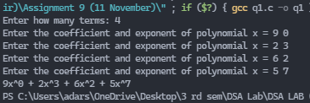

Q2. WAP by modifying the first program to add two polynomials with single variable. Use the same function in first prog. written for creation & display operations and write a new function for addition operations.

#include <stdio.h>

#include <stdlib.h>

struct node

{

    int coeff;

    int exp;

    struct node \*next;

};

void create(struct node \*\**head*)

{

    int noOfTerms;

    printf("Enter how many terms: ");

    scanf("%d", &noOfTerms);

    struct node \*ptr, \*current;

    for (int i = 0; i < noOfTerms; i++)

    {

        current = malloc(sizeof(struct node));

        current->next = NULL;

        printf("Enter the coefficient and exponent of polynomial x = ");

        scanf("%d%d", &current->coeff, &current->exp);

        if (\**head* == NULL)

        {

            \**head* = current;

            ptr = current;

        }

        else

        {

            ptr->next = current;

            ptr = current;

        }

    }

}

void display(struct node \**head*)

{

    struct node \*current = *head*;

    while (current != NULL)

    {

        printf("%dx^%d", current->coeff, current->exp);

        current = current->next;

        if (current != NULL && current->coeff >= 0)

            printf(" + ");

        else

            printf(" ");

    }

    printf("\n");

}

void join(struct node \*\**h1*, struct node \**h2*)

{

    struct node \*ptr;

    if (\**h1* == NULL)

        \**h1* = *h2*;

    else

    {

        for (ptr = \**h1*; ptr->next != NULL; ptr = ptr->next)

            ;

        ptr->next = *h2*;

    }

}

void addition(struct node \*\**h*)

{

    struct node \*ptr, \*ptr1, \*prev;

    for (ptr = \**h*; ptr != NULL; ptr = ptr->next)

    {

        prev = ptr;

        ptr1 = ptr->next;

        while (ptr1 != NULL)

        {

            if (ptr1->exp == ptr->exp)

            {

                ptr->coeff = ptr->coeff + ptr1->coeff;

                prev->next = ptr1->next;

                free(ptr1);

                ptr1 = prev;

            }

            prev = ptr1;

            ptr1 = ptr1->next;

        }

    }

}

int main()

{

    struct node \*h1 = NULL, \*h2 = NULL;

    printf("Creation of Polynomial p\n");

    create(&h1);

    printf("Creation of Polynomial q\n");

    create(&h2);

    printf("The polynomial p = ");

    display(h1);

    printf("The polynomial q = ");

    display(h2);

    printf("The polynomial p + q is r = ");

    join(&h1, h2);

    addition(&h1);

    display(h1);

    return 0;

}

OUTPUT:-

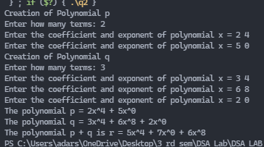

Q3 A matrix m × n that has relatively few non-zero entries is called sparse matrix. It may be represented in much less than m × n space. An m × n matrix with k non-zero entries is sparse if k << m × n. It may be faster to represent the matrix compactly as a list of the non-zero indexes and associated entries. WAP to represent a sparse matrix using linked list.

#include <stdio.h>

#define size 20

void getData(int *a*[size][size], int *row*, int *column*)

{

    for (int i = 0; i < *row*; i++)

    {

        for (int j = 0; j < *column*; j++)

        {

            scanf("%d", &*a*[i][j]);

        }

    }

}

void create(int *a*[size][size], int *row*, int *column*, int *b*[size][3])

{

    int k = 0;

*b*[0][0] = *row*;

*b*[0][1] = *column*;

    for (int i = 0; i < *row*; i++)

    {

        for (int j = 0; j < *column*; j++)

        {

            if (*a*[i][j] != 0)

            {

*b*[k][0] = i;

*b*[k][1] = j;

*b*[k][2] = *a*[i][j];

                k++;

            }

        }

*b*[0][2] = k;

    }

}

void display(int *b*[size][3])

{

    int column = *b*[0][2];

    printf("Row Column   Value\n");

    for (int i = 0; i < column; i++)

    {

        printf("%d\t%d\t%d\n", *b*[i][0], *b*[i][1], *b*[i][2]);

    }

}

int main()

{

    int row, column;

    printf("Enter the row & columns of the source matrix: ");

    scanf("%d%d", &row, &column);

    int arr[row][column], arr2[size][3];

    getData(arr, row, column);

    create(arr, row, column, arr2);

    display(arr2);

    return 0;

}

OUTPUT:-

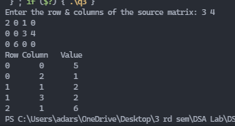

Q4. WAP to find out the transpose of a sparse matrix.

#include <stdio.h>

#include <stdlib.h>

struct node

{

    int row;

    int column;

    int val;

    struct node \*next;

};

void create(struct node \*\**head*)

{

    struct node \*ptr, \*current;

    \**head* = malloc(sizeof(struct node));

    (\**head*)->next = NULL;

    printf("Enter the row,column and no of values of matrix: ");

    scanf("%d%d%d", &(\**head*)->row, &(\**head*)->column, &(\**head*)->val);

    ptr = \**head*;

    for (int i = 0; i < (\**head*)->val; i++)

    {

        current = malloc(sizeof(struct node));

        current->next = NULL;

        printf("Enter row, column and value: ");

        scanf("%d%d%d", &current->row, &current->column, &current->val);

        ptr->next = current;

        ptr = current;

    }

}

void transpose(struct node \*\**A*)

{

    struct node \*ptr;

    int temp;

    for (ptr = \**A*; ptr != NULL; ptr = ptr->next)

    {

        temp = ptr->row;

        ptr->row = ptr->column;

        ptr->column = temp;

    }

}

void display(struct node \**head*)

{

    struct node \*current = *head*;

    printf("Row Column Value\n");

    while (current != NULL)

    {

        printf("%d\t%d\t  %d", current->row, current->column, current->val);

        current = current->next;

        printf("\n");

    }

    free(current);

    printf("\n");

}

int main()

{

    struct node \*A;

    A = NULL;

    create(&A);

    transpose(&A);

    display(A);

    return 0;

}

OUTPUT:-

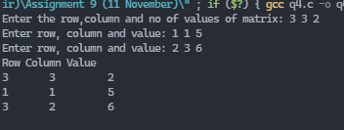

Q5. WAP to determine whether the given matrix is a sparse matrix or not.

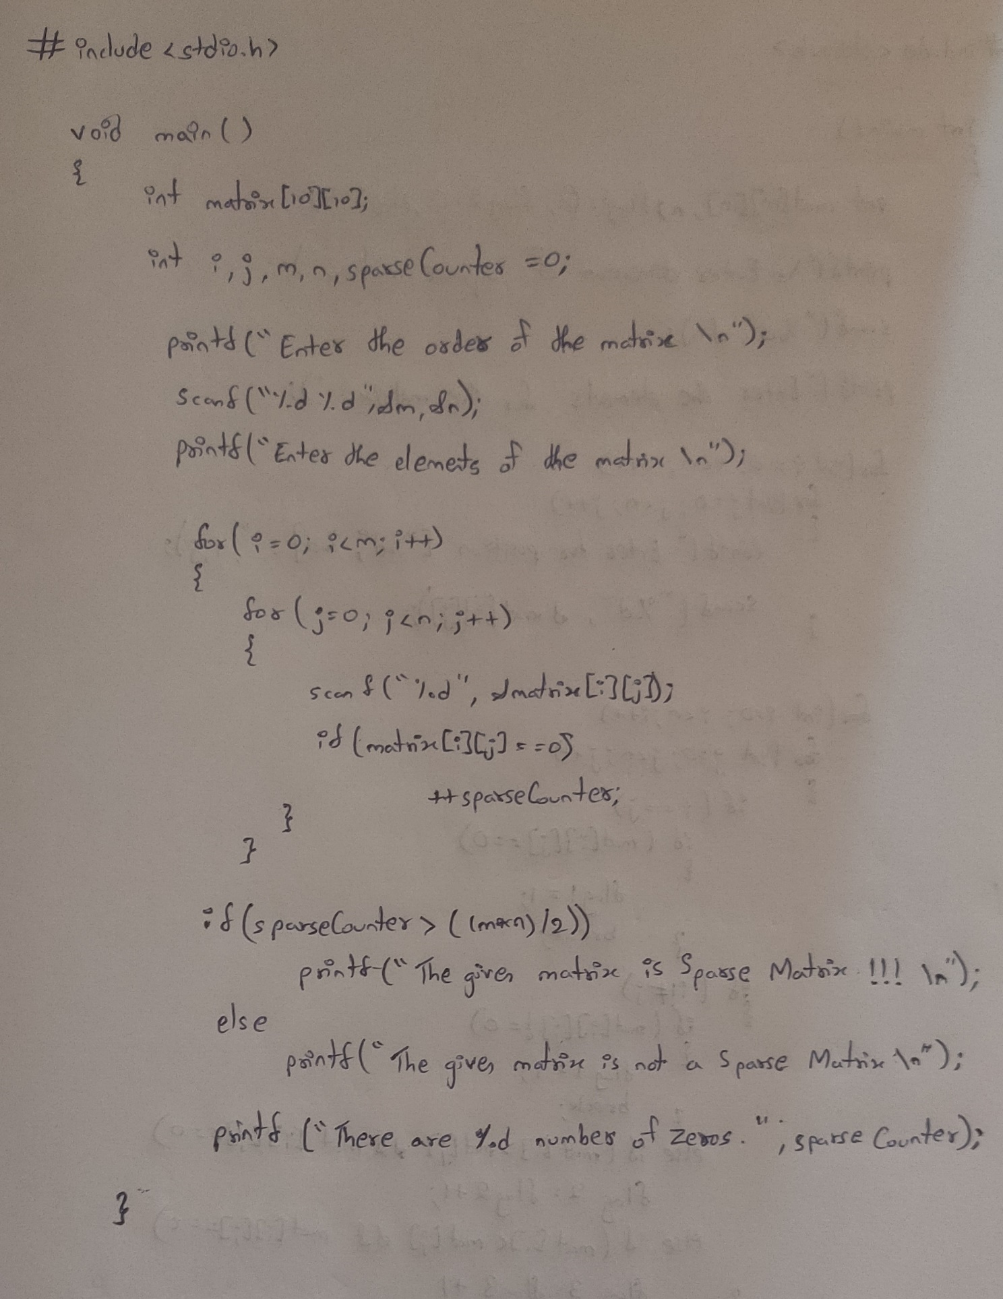

OUTPUT:-

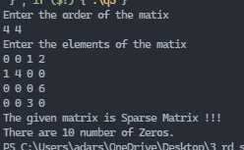

Q6. WAP to determine whether the given matrix is a lower triangular or upper triangular or tri-diagonal matrix.

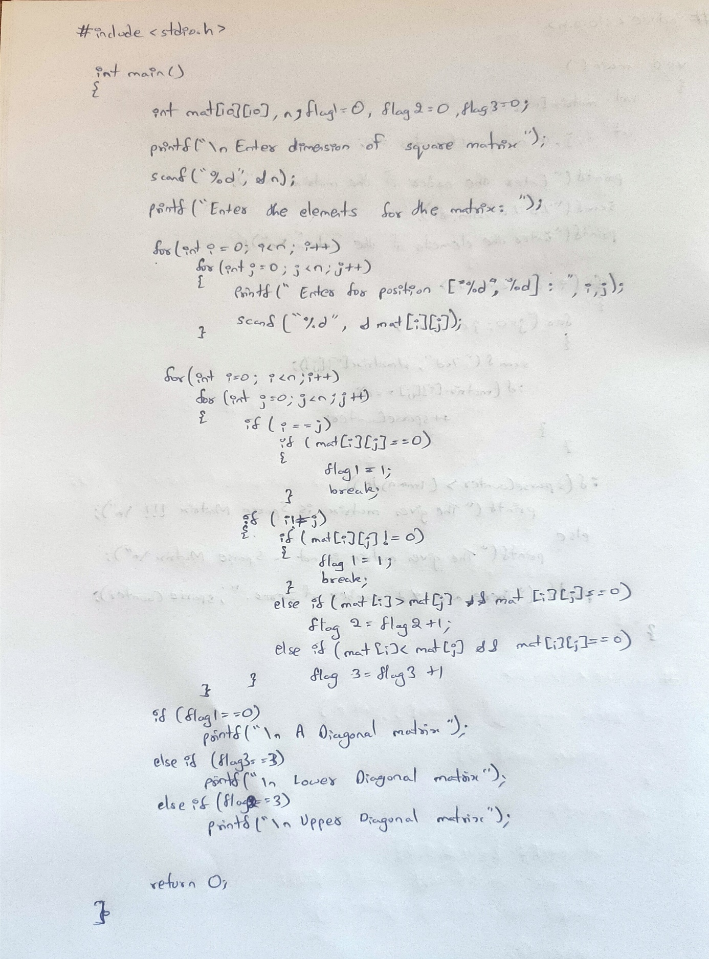

OUTPUT:-

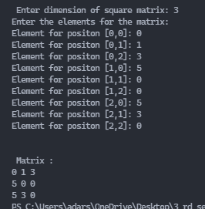

Q7. WAP to add two sparse matrixes.

#include <stdio.h>

#include <stdlib.h>

struct node

{

    int row;

    int column;

    int val;

    struct node \*next;

};

void create(struct node \*\**head*)

{

    struct node \*ptr, \*current;

    \**head* = malloc(sizeof(struct node));

    (\**head*)->next = NULL;

    printf("Enter the row,column and no of values of matrix: ");

    scanf("%d%d%d", &(\**head*)->row, &(\**head*)->column, &(\**head*)->val);

    ptr = \**head*;

    for (int i = 0; i < (\**head*)->val; i++)

    {

        current = malloc(sizeof(struct node));

        current->next = NULL;

        printf("Enter row, column and value: ");

        scanf("%d%d%d", &current->row, &current->column, &current->val);

        ptr->next = current;

        ptr = current;

    }

}

void addition(struct node \**A*, struct node \**B*, struct node \*\**C*)

{

    struct node \*ptr, \*ptr1, \*current, \*prev;

    if (*A*->row != *B*->row || *A*->column != *B*->column)

        return;

    \**C* = malloc(sizeof(struct node));

    (\**C*)->row = *A*->row;

    (\**C*)->column = *A*->column;

    (\**C*)->val = *A*->val + *B*->val;

    (\**C*)->next = NULL;

    ptr = \**C*;

    for (ptr1 = *A*->next; ptr1 != NULL; ptr1 = ptr1->next)

    {

        current = malloc(sizeof(struct node));

        current->row = ptr1->row;

        current->column = ptr1->column;

        current->val = ptr1->val;

        current->next = NULL;

        ptr->next = current;

        ptr = current;

    }

    for (ptr1 = *B*->next; ptr1 != NULL; ptr1 = ptr1->next)

    {

        current = malloc(sizeof(struct node));

        current->row = ptr1->row;

        current->column = ptr1->column;

        current->val = ptr1->val;

        current->next = NULL;

        ptr->next = current;

        ptr = current;

    }

    for (ptr = (\**C*)->next; ptr != NULL; ptr = ptr->next)

    {

        prev = ptr;

        ptr1 = ptr->next;

        while (ptr1 != NULL)

        {

            if (ptr->row == ptr1->row && ptr->column == ptr1->column)

            {

                ptr->val += ptr1->val;

                prev->next = ptr1->next;

                free(ptr1);

                ptr1 = prev;

                (\**C*)->val--;

            }

            prev = ptr1;

            ptr1 = ptr1->next;

        }

    }

}

void display(struct node \**head*)

{

    struct node \*current = *head*;

    printf("Row Column Value\n");

    while (current != NULL)

    {

        printf("%d\t%d\t  %d", current->row, current->column, current->val);

        current = current->next;

        printf("\n");

    }

    free(current);

    printf("\n");

}

int main()

{

    struct node \*A, \*B, \*C;

    A = B = C = NULL;

    create(&A);

    create(&B);

    addition(A, B, &C);

    display(C);

    return 0;

}

OUTPUT:-

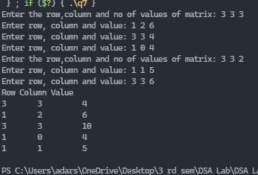

Q8. WAP to multiply two sparse matrixes.

#include <stdio.h>

#include <stdlib.h>

struct node

{

    int row;

    int column;

    int val;

    struct node \*next;

};

void create(struct node \*\**head*)

{

    struct node \*ptr, \*current;

    \**head* = malloc(sizeof(struct node));

    (\**head*)->next = NULL;

    printf("Enter the row,column and no of values of matrix: ");

    scanf("%d%d%d", &(\**head*)->row, &(\**head*)->column, &(\**head*)->val);

    ptr = \**head*;

    for (int i = 0; i < (\**head*)->val; i++)

    {

        current = malloc(sizeof(struct node));

        current->next = NULL;

        printf("Enter row, column and value: ");

        scanf("%d%d%d", &current->row, &current->column, &current->val);

        ptr->next = current;

        ptr = current;

    }

}

void multiplication(struct node \**A*, struct node \**B*, struct node \*\**C*)

{

    struct node \*ptr, \*ptr1, \*current, \*prev;

    if (*A*->column != *B*->row)

        return;

    \**C* = malloc(sizeof(struct node));

    (\**C*)->row = *A*->row;

    (\**C*)->column = *A*->column;

    (\**C*)->val = 0;

    (\**C*)->next = NULL;

    ptr = \**C*;

    for (ptr = *A*->next; ptr != NULL; ptr = ptr->next)

    {

        for (ptr1 = *B*->next; ptr1 != NULL; ptr1 = ptr1->next)

        {

            if (ptr->column == ptr1->row)

            {

                current = malloc(sizeof(struct node));

                current->row = ptr->row;

                current->column = ptr1->column;

                current->val = ptr->val \* ptr1->val;

                current->next = NULL;

                ptr->next = current;

                ptr = current;

                (\**C*)->val++;

            }

        }

    }

    for (ptr = (\**C*)->next->next; ptr != NULL; ptr = ptr->next)

    {

        prev = ptr;

        ptr1 = ptr->next;

        while (ptr1 != NULL)

        {

            if (ptr->row == ptr1->row && ptr->column == ptr1->column)

            {

                ptr->val = ptr->val + ptr1->val;

                prev->next = ptr1->next;

                free(ptr);

                ptr1 = prev;

                (\**C*)->val--;

            }

            prev = ptr1;

            ptr1 = ptr1->next;

        }

    }

}

void display(struct node \**head*)

{

    struct node \*current = *head*;

    printf("Row Column Value\n");

    while (current != NULL)

    {

        printf("%d\t%d\t  %d", current->row, current->column, current->val);

        current = current->next;

        printf("\n");

    }

    free(current);

    printf("\n");

}

int main()

{

    struct node \*A, \*B, \*C;

    A = B = C = NULL;

    create(&A);

    create(&B);

    multiplication(A, B, &C);

    display(C);

    return 0;

}

OUTPUT:-

